Campus Course & Records Manager (CCRM)

Overview
The Campus Course & Records Manager (CCRM) is a console-based Java application built with Java SE to manage students, courses, enrollments, grades, and file operations for an educational institute. It demonstrates Object-Oriented Programming (OOP) principles (Encapsulation, Inheritance, Abstraction, Polymorphism), NIO.2 for file operations, Java Streams API, modern Date/Time API, design patterns (Singleton, Builder), custom exceptions, and a menu-driven CLI interface.

Features
- Student Management: Add, list, update, deactivate students, and print profiles/transcripts.
- Course Management: Add, list, update, deactivate, and search courses by department, instructor, or semester.
- Enrollment & Grading: Enroll/unenroll students in courses, record marks, compute letter grades and GPA.
- File Operations: Import/export data in CSV format, create timestamped backups, and calculate backup directory size recursively.
- Reports: Generate GPA distribution reports using Streams.

Project Structure
CCRM/
├── src/
│ ├── edu/
│ │ ├── ccrm/
│ │ │ ├── cli/
│ │ │ │ └── Main.java
│ │ │ ├── config/
│ │ │ │ └── AppConfig.java
│ │ │ ├── domain/
│ │ │ │ ├── Course.java
│ │ │ │ ├── CourseCode.java
│ │ │ │ ├── Enrollment.java
│ │ │ │ ├── Grade.java
│ │ │ │ ├── Instructor.java
│ │ │ │ ├── Person.java
│ │ │ │ ├── Persistable.java
│ │ │ │ └── Student.java
│ │ │ ├── io/
│ │ │ │ ├── BackupService.java
│ │ │ │ └── ImportExportService.java
│ │ │ ├── service/
│ │ │ │ ├── CourseService.java
│ │ │ │ ├── EnrollmentService.java
│ │ │ │ ├── StudentService.java
│ │ │ │ └── TranscriptService.java
│ │ │ └── util/
│ │ │ ├── DuplicateEnrollmentException.java
│ │ │ ├── MaxCreditLimitExceededException.java
│ │ │ └── RecursiveUtil.java
└── README.md

Prerequisites
- JDK 17+: Install from oracle.com/java/technologies/downloads.
- Visual Studio Code: Install from code.visualstudio.com with the Java Extension Pack.
- Git: Install from git-scm.com for version control (optional).

Setup Instructions

1. Install Java
• Download and install JDK 17+.
• Set JAVA_HOME to the JDK path (e.g., C:\Program Files\Java\jdk-17 on Windows).
• Add %JAVA_HOME%\bin to your PATH environment variable.
• Verify installation:
java -version
- Save the output as screenshots/java-version.png.

2. Set Up VS Code
• Open VS Code and select File > Open Folder, choosing the CCRM folder.
• Install the Java Extension Pack:
- Go to Extensions (Ctrl+Shift+X or Cmd+Shift+X).
- Search for Java Extension Pack by Microsoft and install.
• Create .vscode/settings.json:
{
"java.project.sourcePaths": ["src"],
"java.project.outputPath": "bin",
"java.project.referencedLibraries": []
}
- Save screenshot as screenshots/vscode-setup.png.

3. Clone or Create the Project
• Clone the repository (if hosted on GitHub):
git clone <repository-url>
cd CCRM
• Alternatively, create the project structure manually and copy provided source files under src/edu/ccrm/.
• Create a data folder in the root for runtime file operations.
• Copy sample CSV data:
ID,RegNo,FullName,Email,DOB
1,REG001,John Doe,john@example.com,2000-01-01
2,REG002,Jane Smith,jane@example.com,2001-02-02

4. Compile and Run
• Open a terminal in the CCRM folder.
• Compile:
javac -d bin src/edu/ccrm/cli/Main.java
Run with assertions enabled:
java -ea -cp bin edu.ccrm.cli.Main
- Alternatively, run from VS Code by clicking Run in Main.java.
- Capture CLI output as screenshots/program-run.png.

5. Perform a Backup
- In CLI, select option 6 to create a backup.
- Check data/backups/ for a timestamped folder.
- Capture as screenshots/backup-folder.png.

Running the Application
The app starts with:
Welcome to Campus Course & Records Manager (CCRM)
Data folder: data
Menu:
1. Manage Students
2. Manage Courses
3. Manage Enrollments
4. Manage Grades
5. Import/Export Data
6. Backup & Show Backup Size
7. Reports
8. Exit

Evolution of Java
- 1995: Java 1.0 released.
- 2004: Java 5 introduced generics, enums, annotations.
- 2014: Java 8 added lambdas, Streams, Date/Time API.
- 2021: Java 17 (LTS) added sealed classes, pattern matching.

Java ME vs SE vs EE
Platform | Description
Java ME | Micro Edition for constrained devices (mobiles, embedded).
Java SE | Standard Edition for desktop/server apps (used here).
Java EE | Enterprise Edition for distributed, large-scale systems.

JDK, JRE, JVM
- JDK: Development kit with compiler, debugger.
- JRE: Runtime environment for execution.
- JVM: Executes bytecode.
- Interaction: JDK compiles → JRE provides libs → JVM executes.

Syllabus Mapping
Topic | File/Class/Method
Encapsulation | domain/Person.java (private fields, getters/setters)
Inheritance | domain/Student.java, domain/Instructor.java extend Person
Abstraction | domain/Person.java (abstract class, displayInfo)
Polymorphism | service/TranscriptService.java (toString overrides)
Singleton Pattern | config/AppConfig.java (getInstance)
Builder Pattern | domain/Course.java (inner Builder class)
Custom Exceptions | util/DuplicateEnrollmentException.java, util/MaxCreditLimitExceededException.java
Streams API | service/CourseService.java (searchCoursesByDepartment)
NIO.2 | io/BackupService.java (backup), io/ImportExportService.java (import/export)
Date/Time API | domain/Enrollment.java (enrollmentDate)
Loops & Decisions | cli/Main.java (switch, while, for loops)
Assertions | service/StudentService.java (ID validation)

Enabling Assertions
Run with:
java -ea -cp bin edu.ccrm.cli.Main

Screenshots
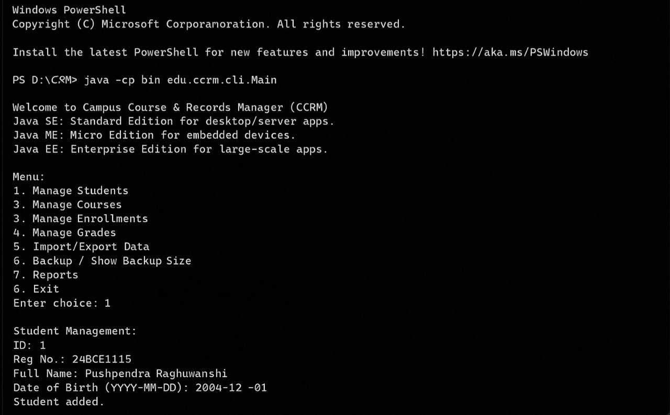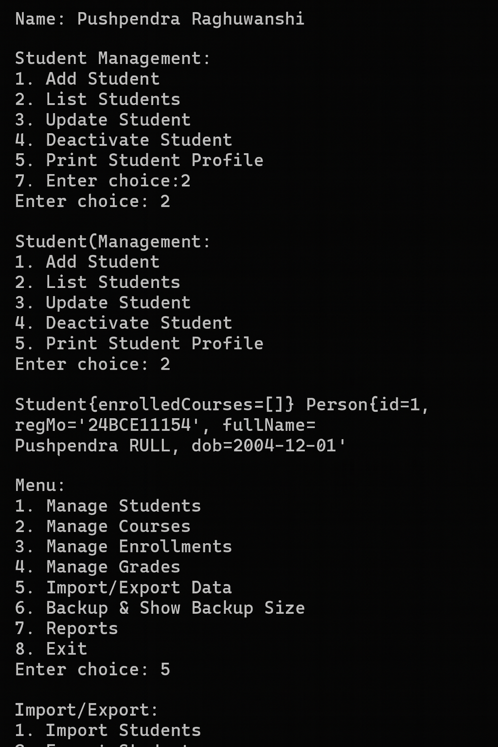

Sample Data
test-data/students.csv:
ID,RegNo,FullName,Email,DOB
1,REG001,John Doe,john@example.com,2000-01-01
2,REG002,Jane Smith,jane@example.com,2001-02-02

